|  |  |
| --- | --- |
| **Bloom taxonomy – cognitive dimension** | |
| Remembering | recognising and recalling |
| **Understanding** | Interpreting, Exemplifying, Classifying, Summarising, Inferring, Comparing, and Explaining. |
| **Applying** | Ability to execute algorithms, track and recognize their goals |
| Analyzing | Differentiating, Organising, and Attributing. |
| Evaluating | Checking and Critiquing |
| **Creating** | Ability to plan or produce programs or algorithms |

1. Loops
2. Parallelization
3. Coordination/Events/Broadcasts
4. Conditionals
5. Operators
6. Data/Variables
7. Procedures

(Just for ourselves, the questions have an identifier for which category and concept they are, eg RU3 means Remembering & Understanding of Coordination/Events/Broadcasts)

1. RU3: What is the difference between the instruction Say hello and the instruction broadcast hello?
   1. say hello makes “Hello” be written in a bubble on top of the sprite, while broadcast hello will send a signal to all other sprites
   2. they do the same thing, there is no difference
   3. broadcast hello makes “HELLO” be written in capital letters on top of all sprites
2. U1,4: What is the first one equivalent to?

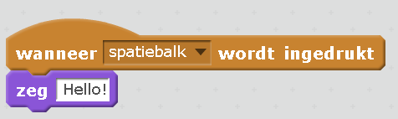

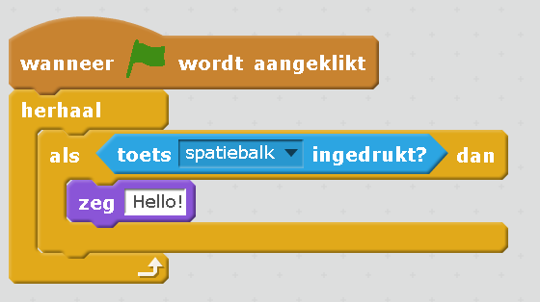

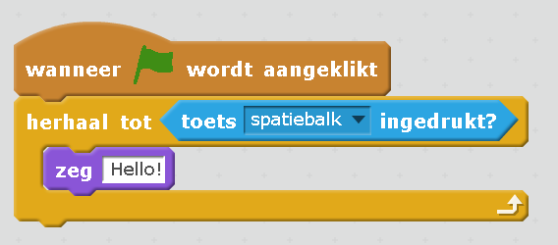

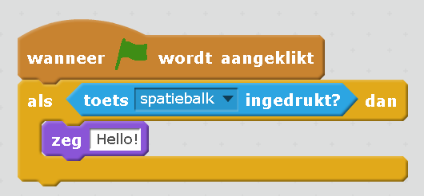

1. RU6:This is the program with one sprite, a Cat. Are there any variables used? Which?

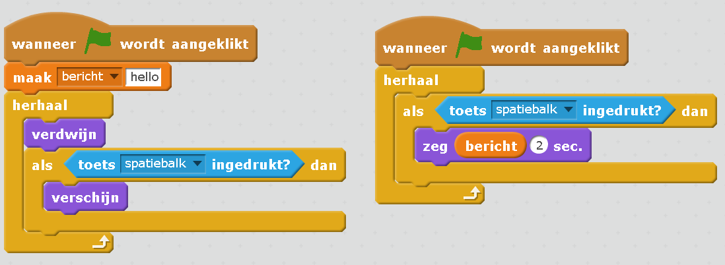

1. U2,1 What happens when we execute this program (hit the green flag)?
   1. The cat is there and says something every time we hit the space button
   2. Nothing is on the screen until we hit the space button. Every time we hit the space button, a cat appears and something
   3. Nothing is on the screen until we hit the space button. When we hit the space button, a cat appears and stays there.
2. UE7,1,4 The following code will make the sprite jump up and return when the space key is pressed. What is it equivalent to?

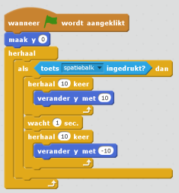

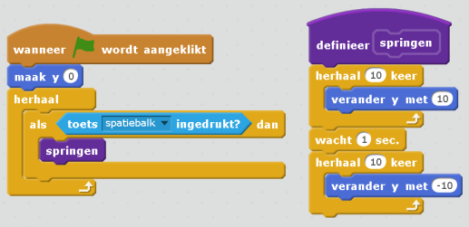

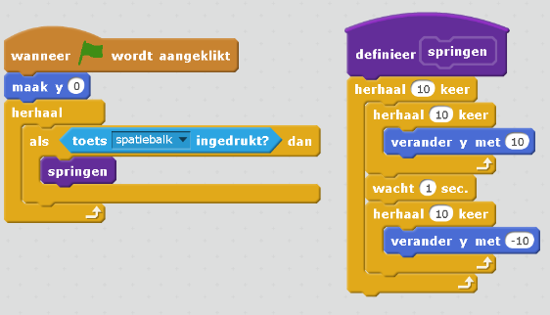

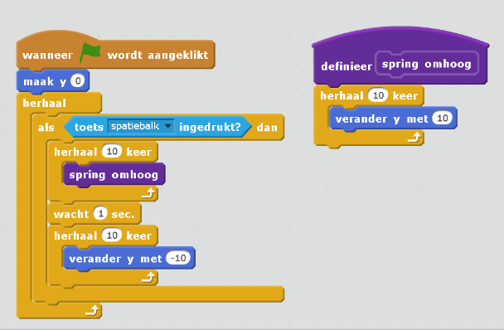

1. RAn7 What is the block sprigen?
   1. A custom block created by the programmer
   2. A custom block of type Beweging
   3. A standard block of type Beweging

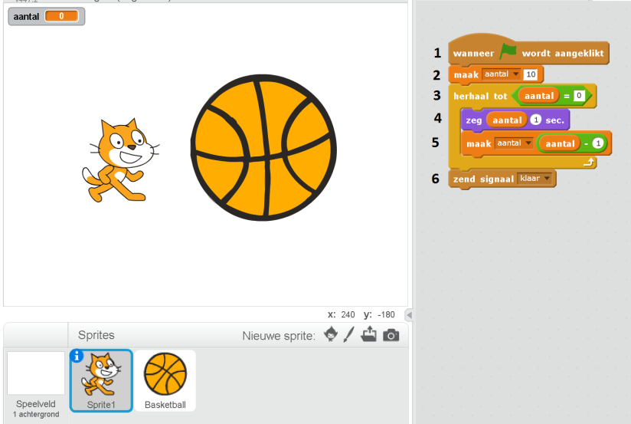

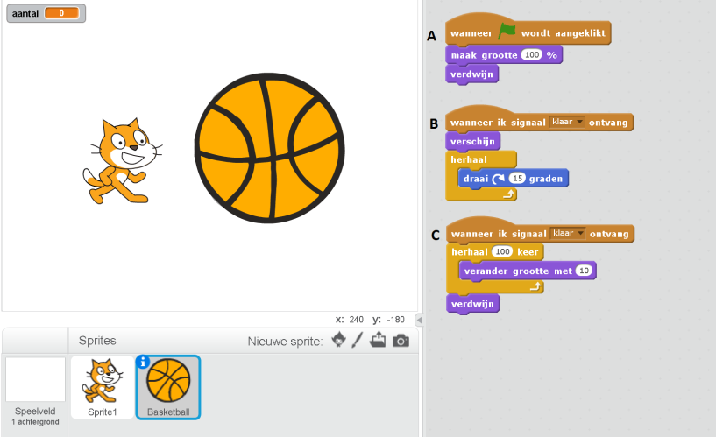

1. Ap1,5,6: In the program above, what does the cat say?
   1. “aantal”
   2. 10,9,8,7,6,5,4,3,2,1
   3. 10,9,8,7,6,5,4,3,2,1,0,-1,-2,….
   4. nothing
2. Ap1,2,3,5,6: In the program above, what happens when we hit the green flag?
   1. There is a cat and a ball, the cat counts down and then nothing happens
   2. There is a cat and a ball, the cat counts down and then the ball becomes bigger and spins forever
   3. There is a cat that counts down and then the ball appears, becomes bigger and spins for some time and then disappears
   4. There is a cat that counts down and then the ball appears, becomes bigger for some time and then disappears
   5. There is a cat that counts down and then the ball appears and spins forever
3. R1: Which block makes the ball spin continuously instead of turning only once?
   1. The draai block in script B
   2. The herhaal block in script B
   3. The herhall block in script C
4. R2: There are two scripts (B and C) that begin by receiving signal klaar. How are they executed?
   1. First B and then C
   2. They are executed simultaneously
   3. It varies, there is no way to determine which is executed first
5. An2,3 Which code blocks are responsible for activating the ball when count down finishes?
   1. A, B and C
   2. B and C
   3. B
6. RAn5,6 Which block makes the cat count down instead of count up?
   1. The herhaal block in line 3
   2. The zeg block in line 4
   3. The aantal – 1 in line 5
7. C6,1 What would you need to modify in the Cat sprite to make it count down from 100?
   1. Line 2, maak aantal 100
   2. Line 3, herhaal tot 100
   3. Line 4, zeg 100 1 sec
8. C5 What would you need to modify to make it count down 5 steps at a time?
   1. Line 3, herhaal tot 5
   2. Line 4, zeg 5 1 sec
   3. Line 5, maak aantal aantal - 5
9. C2 What code should we add to the ball sprite to make it also move to the right? (free text)
10. C7 Could you create a function Countdown and use it in the Cat sprite? (free text)

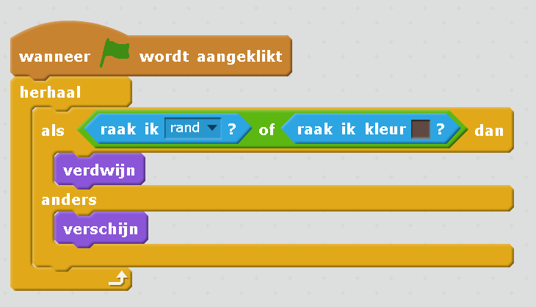

1. RAn4 Which block determines under which conditions the sprite appears?
   1. The herhaal block
   2. The als block
   3. The als & anders block
2. Ap4 In the example above, when does the sprite appear?
   1. when it touches the edge or black
   2. when it does not touch the edge or black
   3. when it touches the edge and black
3. C3,4 We want a message “Game over” to be broadcasted when it touches the edge or black. What block should we ad and where?
   1. A block zeg Game over before the verdwijn block
   2. A block broadcast Game over before the verdwijn block
   3. A block broadcast Game over before the verschijn block
4. Ap7,1 In the program below, what is the final x position after we hit the green flag?
   1. 10
   2. 100
   3. 110

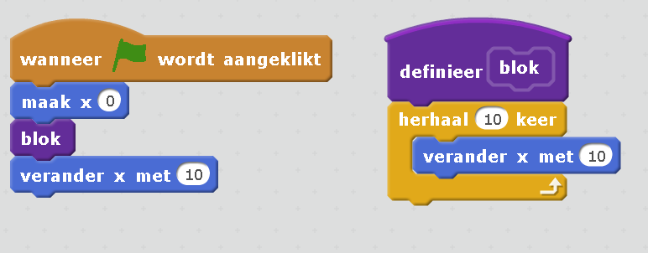

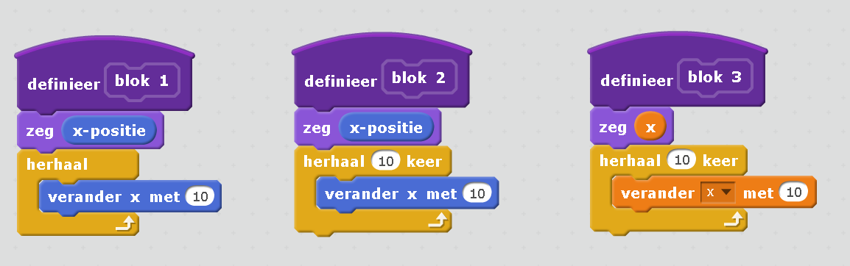

1. An1 What is the difference between blocks 1 and 2?
   1. They are the same
   2. The first increases x one time while the second 10 times
   3. The first increases x indefinitely while the second 10 times
2. RAn6 What is x in blok 3?
   1. the x position of the sprite
   2. a variable
   3. The amount of times the position must increase by 10
3. E1,5,6 We want the sprite to say the multiplication table of 5 when the green flag is clicked, thus

5,10,15,20,25,30,35,40,45,50

Will it do it with the following code?

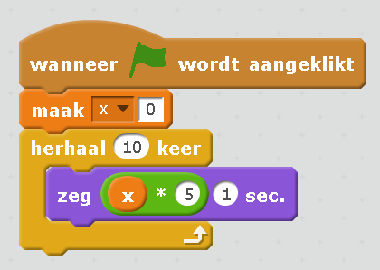

* 1. Yes
  2. No, it will say “x * 5”
  3. No, it will not say anything
  4. No, it will say 0

1. E1,5,6 Will it do it with the following code?

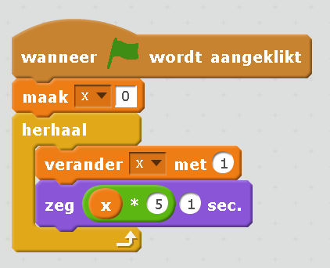

* 1. Yes
  2. No, it will say “x * 5”
  3. No, it will say 5,10,15,20,25,30,35,40,45,50,55,60,… continuing indefinitely
  4. No, it will say 5,5,5, indefinitely

1. E1,5,6,4 Will it do it with the following code?

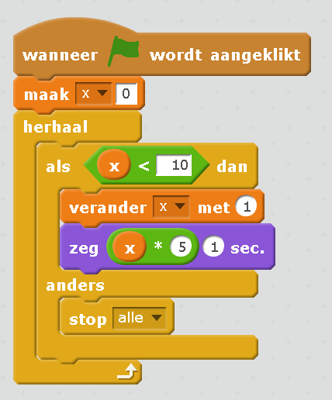

* 1. Yes
  2. No, it will not say anything
  3. No, it will say “x * 5”
  4. No, it will say 5,10,15,20,25,30,35,40,45,50,55,60,… continuing indefinitely

1. E1,5,6,3 Will it do it with the following code?

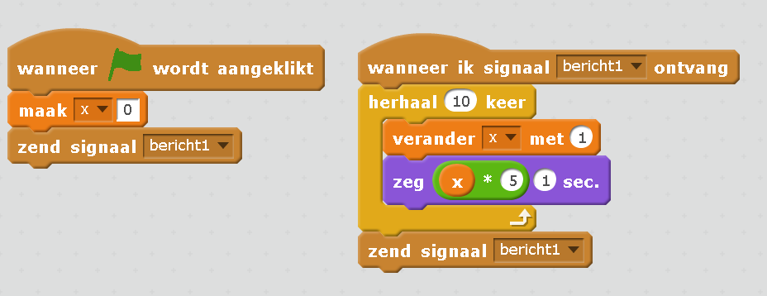

* 1. Yes
  2. No, it will not say anything
  3. No, it will say 5,10,15,20,25,30,35,40,45,50,55,60,… continuing indefinitely
  4. No, it will say 5,5,5, indefinetly